Barbara Han, from the Autodesk Developer Network, updated The Folder Property to work with Vault 2012. The functionality is the same.
The Vault 2010 version can be found here. There is no Vault 2011 version.
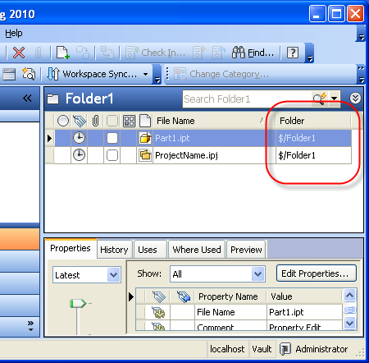
Requirements:
Vault Workgroup/Collaboration/Manufacturing 2012
Click here to download the application
Click here to download the source code
As with all the samples on this site, the legal disclaimer applies.

